Recap of grazing pop-up at Bryce & Jen Riemer’s 9/9/22
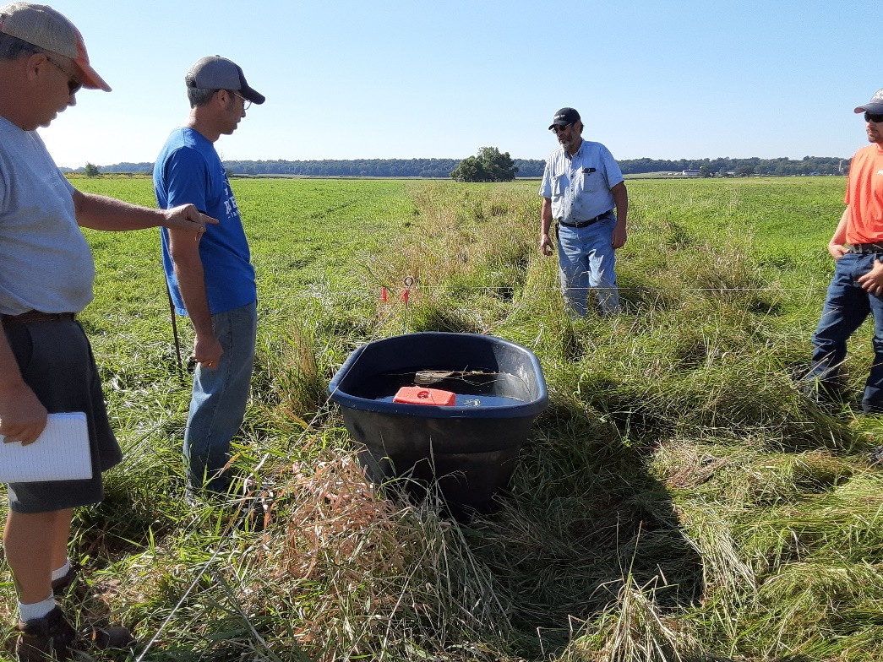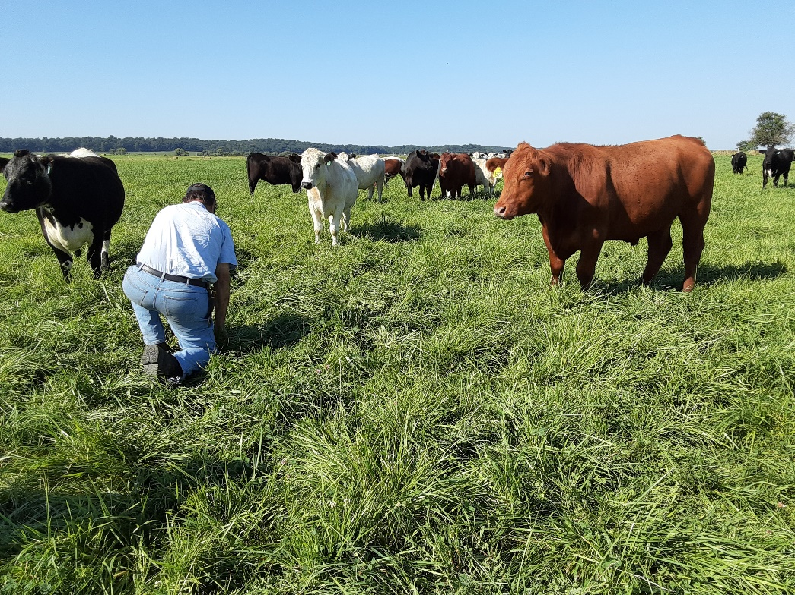
Bryce and Jen came back to his parent’s farm to graze cattle. The couple has a direct marketing side of the farm business that they sell specific cuts or bundles of meat to consumers from their website. They showed the pipeline system they use for watering the cattle on paddocks.
Carl Delafield from Prairie Creek Seed was on hand to talk about grasses & mixes being used in forage situations. Riemers have a mix of 6 or more grasses like soft fescue, meadow fescue, timothy and ryegrass. They also have legumes and forbs in the mix as well. They anticipate pastures to last about 7-8 years. Typically when the pasture turns to a dominant stand of a certain specie then it’s time to renovate it.
They buy 600 lbs steers and put them on pasture. They are harvested at about 1100 lbs. The breeds that they have are White Parks, Herford, Red Angus, and some crossbreds. They are looking for smaller framed cattle for their grazing operation. It takes about 20 months to finish the animals.
Their philosophy for grazing is to take half and leave half. They move the steers once a day. Carl gave a tip on knowing how to tell if a cool season grass is fully recovered- by counting the leaves on the plant- if you have 4 full leaves then the paddock could be grazed again. He strongly suggests not taking grasses lower than 4 inches.

