Recap of Bert Paris’ Grazing Pop-up Day 9/9/22
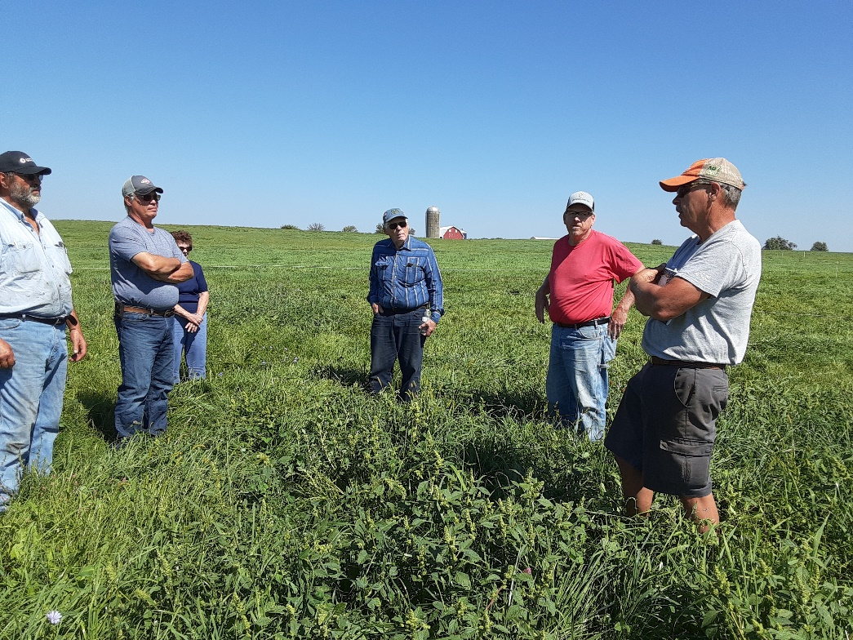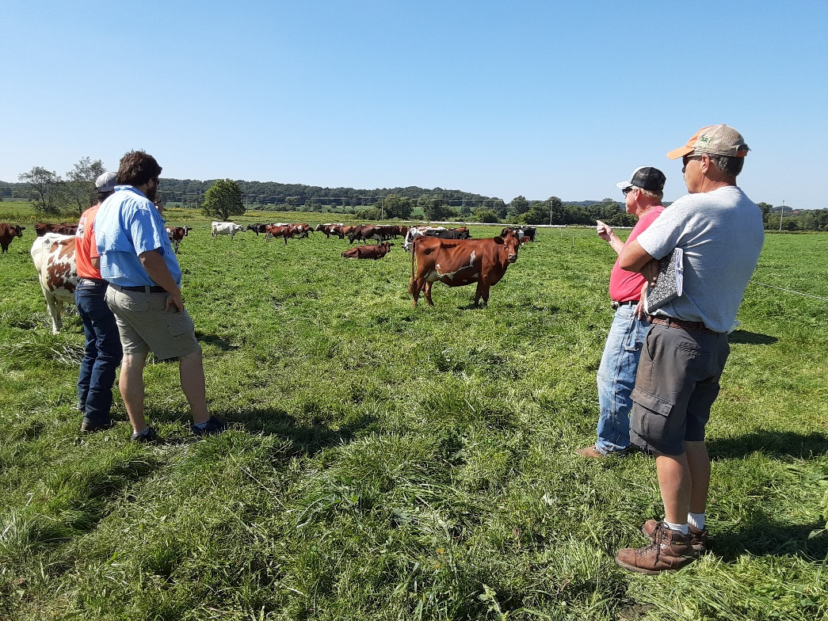
Bert Paris has been grazing dairy cows since 1993. He stopped growing corn on his farm by 2000. He has increased his herd to 80 cows, which he feels is just the right number for his farm. He now grazes about 210 acres from Mid-April until about the end of December. His dairy is a seasonal operation in that he dries up the herd by January 1 and around March 1 they start calving. Cows that aren’t pregnant by January 1 are culled; this has selected his herd to cows that breed back easy. Most of his calves are born in March, typically 50-60. Bert keeps 25 of the calves as replacement heifers and picks a couple bulls to raise, which selects for the characteristics he’s looking for. The bulls get one year of service, then they are sold. He has a rainbow of livestock in his herd. The herd consists of crosses of Holstein, Jersey, Dutch Belted, Milking Shorthorn, Normandy, Ayrshire, Lineback, and a fair amount of German Red Angler.
He became certified organic 4 years ago as his daughter is working to buy into the operation, and it offers better premiums. He has found that pasturing is fun and easy to do. He gives the herd new pasture after each milking (moving the wire every 12 hours). He does give them some supplemental purchased corn in the parlor. He has a system of how he grazes the farm from spring to early winter while also baling 3 crops on some of the land to have bales for winter feeding. He feeds 7- 11 bales at a time over winter on the paddocks. Much like grazing them on the bales- he uses electric polywire to keep them from the entire field of scattered bales by sticking the posts horizontally in the bales to make only certain bales in feeders available. Bert has a mix of clovers- red & white, orchard grass, Kentucky bluegrass and meadow fescue in his pastures that grow well on his soils.

